

First Semester Examination, 2004

Question/Answer Booklet

YEAR 12 CHEMISTRY

Student Name: __________________________________

Time allowed for this paper
Reading time before commencing work: Ten minutes
Working time for paper: Three hours

Material required/recommended for this paper

To be provided by the supervisor
This Question/Answer Booklet
Separate Multiple Choice Answer Sheet
Chemistry Data Sheet (inside front cover of this Question/Answer Booklet)

To be provided by the candidate
Standard Items: Pens, pencils, eraser or correction fluid, ruler
Special Items: A 2B, B or HB pencil for the separate Multiple Choice Answer Sheet and calculators satisfying the conditions set by the Curriculum Council for this subject.

Important note to candidates
No other items may be taken into the examination room. It is your responsibility to ensure that you do not have any unauthorised notes or other items of a non-personal nature in the examination room. If you have any unauthorised material with you, hand it to the supervisor before reading any further.

Course Coordinator: Malcolm Cesareo
Structure of this paper

Part | Number of questions available | Number of questions to be attempted | Suggested working time | Marks available
1 Multiple choice | 30 | ALL | 55 | 60 (30%)
2 Short answers | 10 | ALL | 60 | 70 (35%)
3 Calculations | 7 | ALL | 45 | 50 (25%)
4 Extended answers | 2 | 1 | 20 | 20 (10%)
Total marks |  |  |  | 200 (100%)

Instructions to candidates

1. The rules for the conduct of Tertiary Entrance Examinations are detailed in the booklet TEE Handbook. Sitting this examination implies that you agree to abide by these rules.

2. Answer the questions according to the following instructions:
Part 1 Answer all questions, using a 2B, B or HB pencil, on the separate Multiple Choice Answer Sheet. Do not use a ball point or ink pen.

If you consider that two or more of the alternative responses are correct, choose the one you think is best. If you think you know an answer, mark it even if you are not certain you are correct. Marks will not be deducted for incorrect answers.

Feel free to write or do working on the question paper; many students who score high marks in the Multiple Choice Section do this.

Parts 2, 3 and 4 Write your answers in the spaces provided in this Question/Answer Booklet. A blue or black ball point or ink pen should be used.

Questions containing specific instructions to show working should be answered with a complete, logical, clear sequence of reasoning showing how the final answer was arrived at; correct answers which do not show working will not be awarded full marks.

3. The examiners recommend that you spend your reading time mainly reading the instructions to candidates and Parts 2, 3 and 4.

4. Chemical equations
For full marks, chemical equations should refer only to those species consumed in the reaction and the new species produced. These species may be ions [for example Ag⁺(aq)], molecules [for example NH₃(g), NH₃(aq), CH₃COOH(l), CH3COOH(aq)] or solids [for example BaSO₄(s), Cu(s), Na₂CO₃(s)].

PART 1 (60 marks)

Answer ALL questions in Part 1 on the Separate Multiple Choice Answer Sheet provided, use a 2B, B or HB pencil. Each question in this part is worth 2 marks.
____________________________________________________________________________

A sample of an unknown gas at STP has a density of 1.25 grams per litre. What is the molar mass of this gas?

  - 28.0 g
  - 44.0 g
  - 64.0 g
  - 80.0 g

- What is the net ionic equation for the reaction of HCl(aq) with NaOH(aq)?

- At 20ºC and 101.3 kPa, 3.9 g of methane occupies 5.88 L. If the same volume of another gaseous hydrocarbon at the same temperature and pressure has a mass of 10.7 g, the gas could be

  - C₂H₄
  - C₂H₆
  - C₃H₈
  - C₄H₁₀

- The ion concentrations in 0.25 mol L⁻¹ Al₂(SO₄)₃ are

[Al³⁺] [SO₄²⁻]

(a) 0.25 mol L⁻¹ 0.25 mol L⁻¹
(b) 0.50 mol L⁻¹ 0.75 mol L⁻¹
(c) 0.75 mol L⁻¹ 0.50 mol L⁻¹
(d) 0.10 mol L⁻¹ 0.15 mol L⁻¹

- What is observed when H₂SO₄ is added to a saturated solution of CaSO₄

  - the pH increases
  - the [Ca²⁺] increases
  - bubbles of H₂ are given off
  - additional CaSO₄ precipitates

- Which of the following will NOT produce a precipitate when equal volumes of 0.20 mol L⁻¹ solutions are combined?

  - KOH and CaCl₂
  - Zn(NO₃)₂ and K₃PO₄
  - NaOH and (NH₄)₂S
  - Na₂SO₄ and Pb(NO₃)₂

- A 200.0 mL solution contains 0.050 mol of Ba(NO₃)₂. The concentration of nitrate ions is

  - 0.050 mol L⁻¹
  - 0.10 mol L⁻¹
  - 0.25 mol L⁻¹
  - 0.50 mol L⁻¹

- An experiment is conducted to identify an unknown cation that is present in each of four beakers.

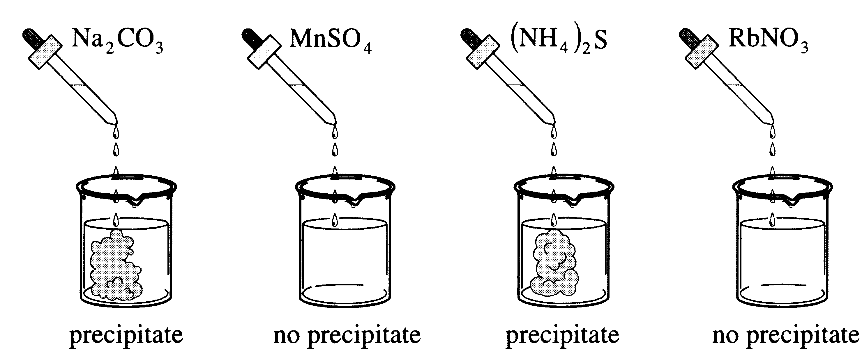

Which of the following could be the unknown cation?

- Ag⁺
- Be²⁺
- Ba²⁺
- K⁺

- An activated complex is a chemical species that is

  - stable and has a low potential energy
  - stable and has a high potential energy
  - unstable and has a low potential energy
  - unstable and has a high potential energy

- Consider the following reaction:

Under certain condition, the rate of decomposition of NO₂ is 3.2 x 10⁻³ mol/s. The rate of formation of O₂ is

  - 1.6 x 10⁻³ mol/s
  - 3.2 x 10⁻³ mol/s
  - 4.8 x 10⁻³ mol/s
  - 6.4 x 10⁻³ mol/s

- Which of the following reactions is accompanied by an increase in enthalpy?

  - + 113 kJ
  - -484 kJ
  - ΔH = +197 kJ
  - ΔH = -111.4 kJ

- Consider the following reaction:

Which of the following diagrams represents what happens to the forward and reverse reaction rates when the catalyst Fe₃O₄ is added?
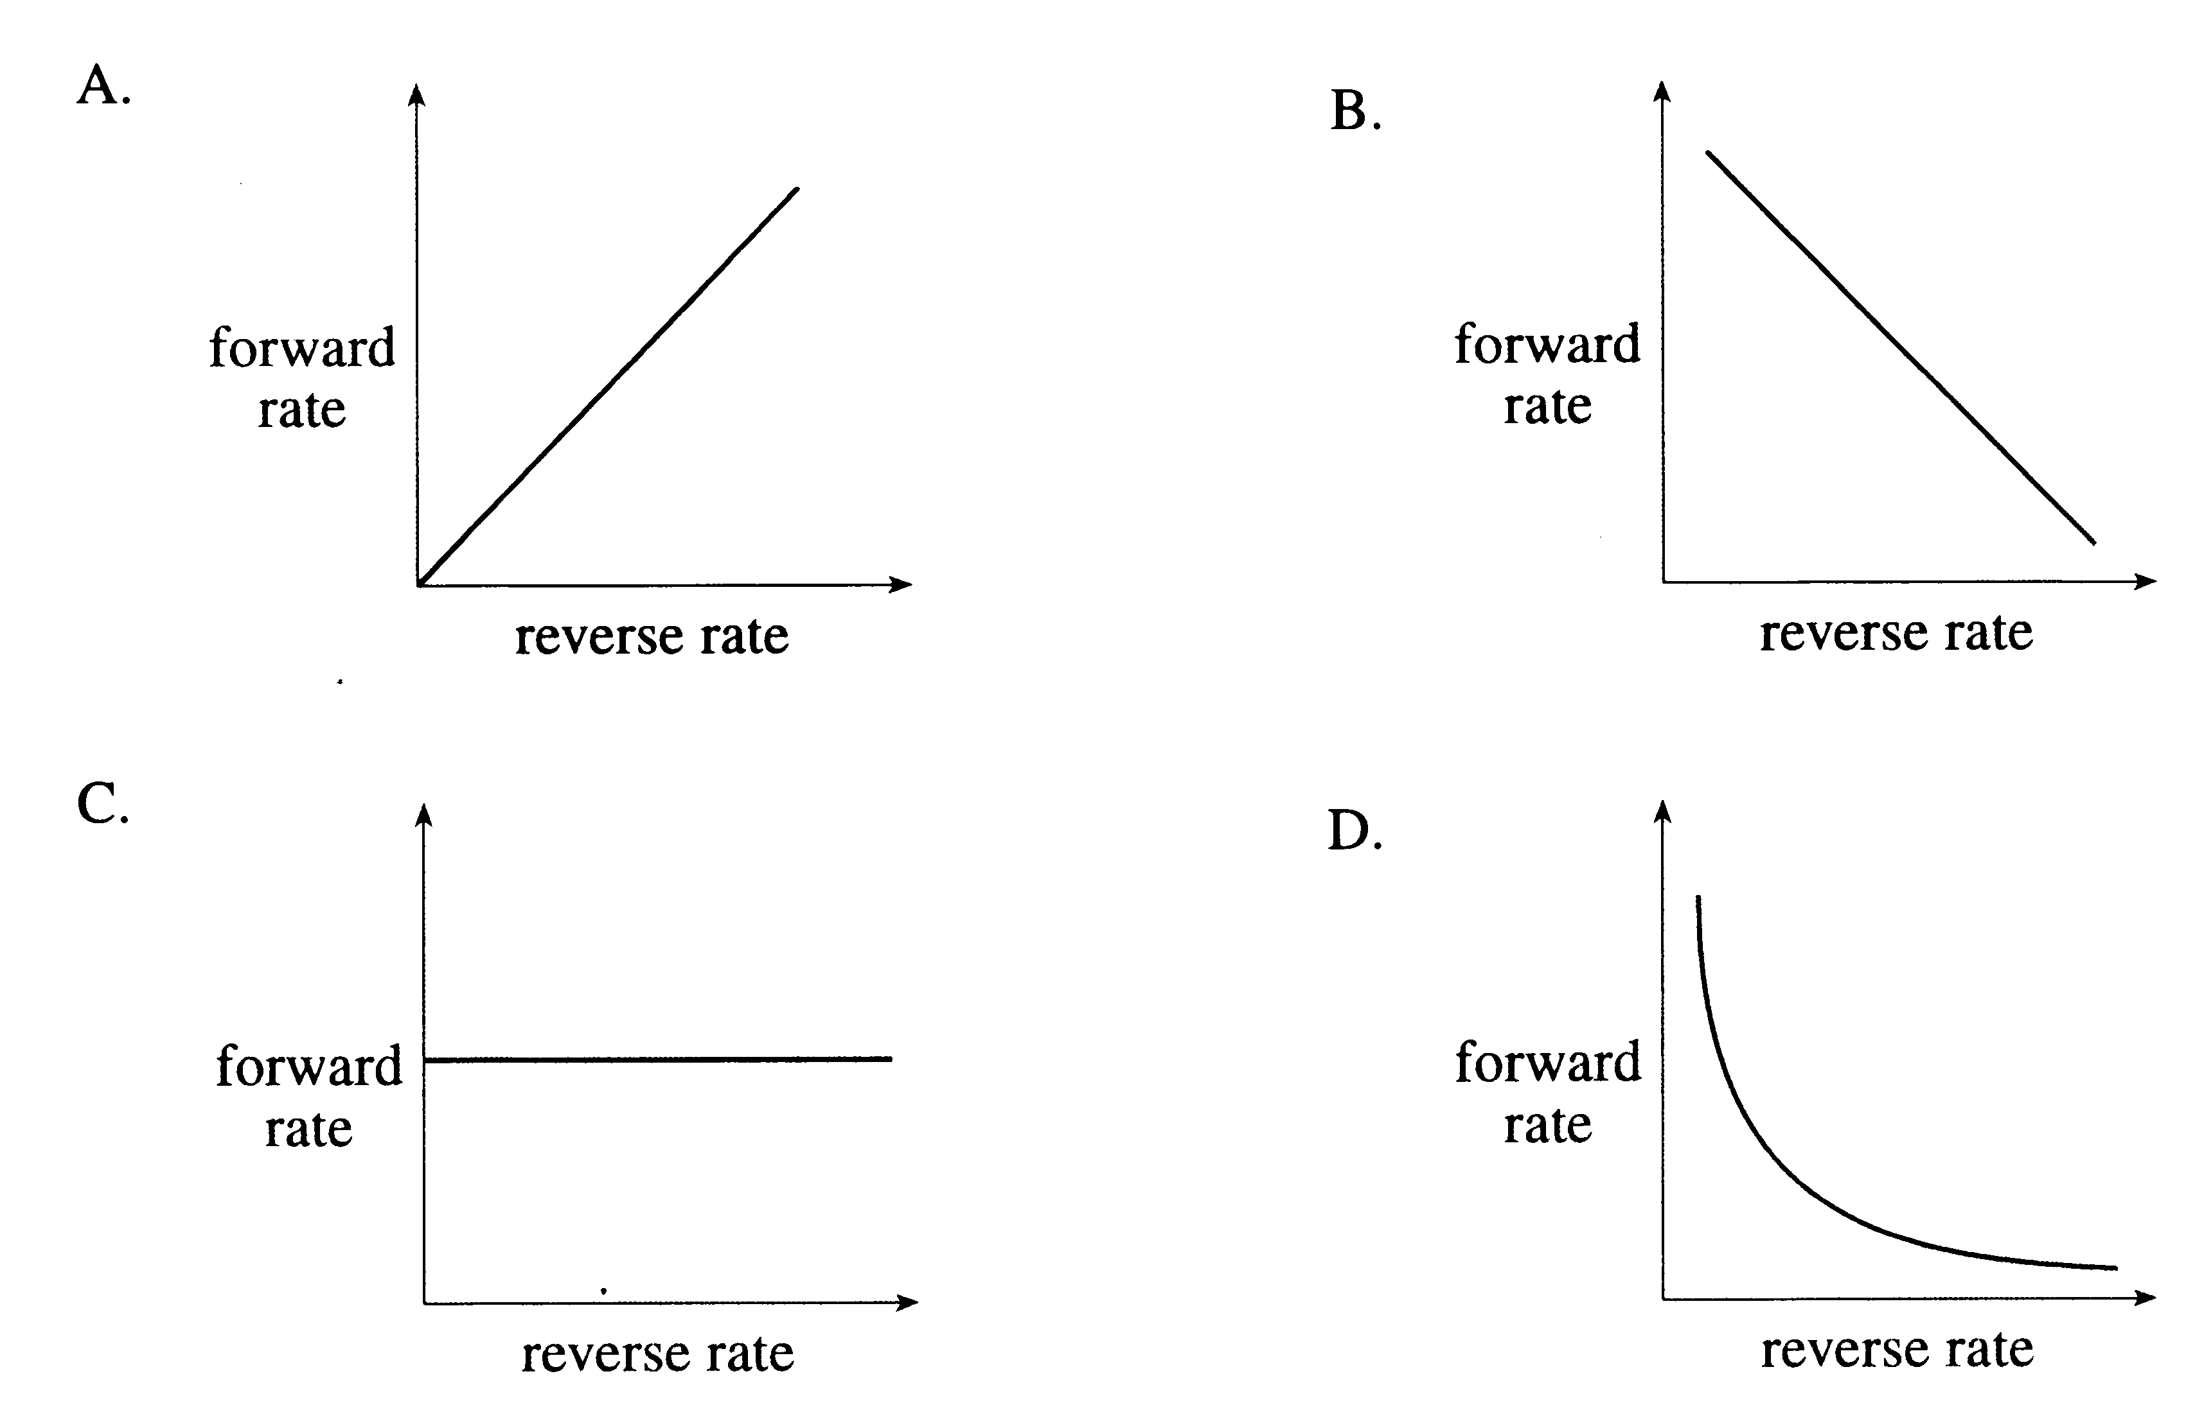

- Hydrogen gas dissociates into atomic hydrogen as follows:

K = 1.2 x 10⁻⁷¹

The value of the equilibrium constant for the above system indicates that

  - the reaction rate is very slow
  - the equilibrium is exothermic
  - reactants are favoured at equilibrium
  - a catalyst is necessary to establish equilibrium

- Consider the following potential energy diagram for an equilibrium system:

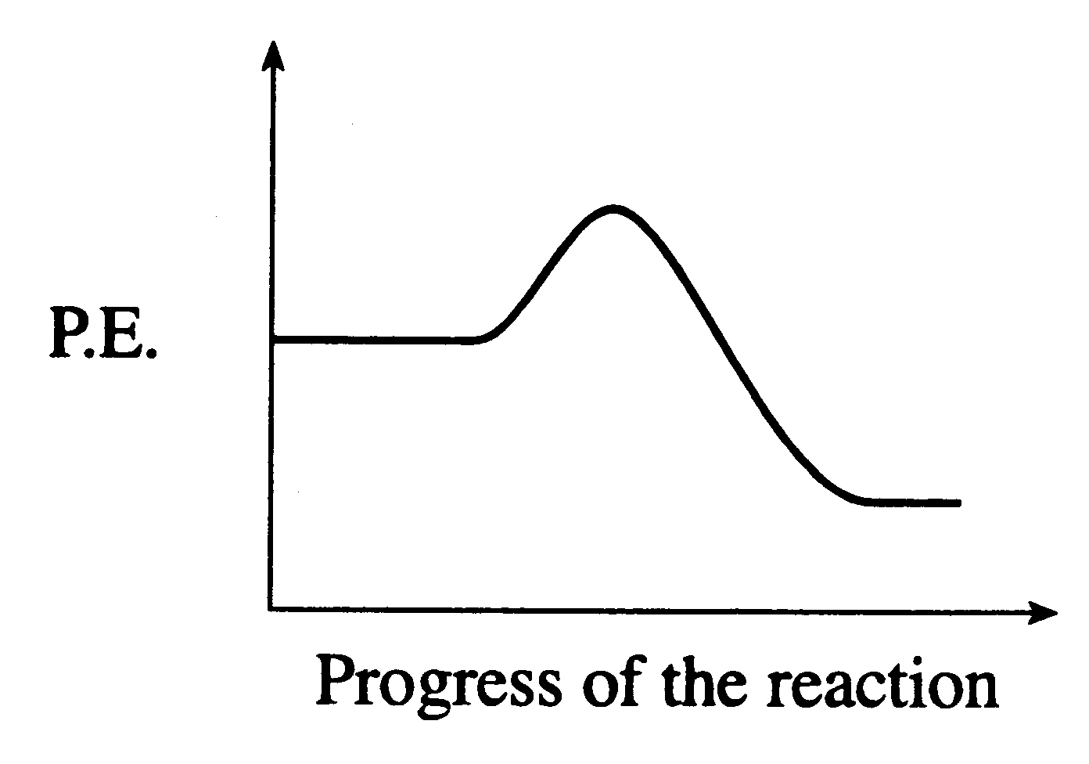

When the temperature of the system is increased, the equilibrium shifts to the

  - left and K increases
  - left and K decreases
  - right and K increases
  - right and K decreases

- Consider the following equilibrium system:

Which one of the following changes would cause the above system to shift left?

  - add more CaO
  - remove CaCO₃
  - decrease volume
  - increase surface area of CaO

- Oxides of nitrogen are formed in air at the high temperatures generated in lightning flashes according to the equation

K = 5 x 10⁻³ at 3000ºC

At 3000ºC, the equilibrium constant for the reaction would be

  - 4 x 10⁴
  - 2 x 10²
  - 2 x 10⁻²
  - 5 x 10⁻³

- Consider the following concentration versus time graph for the equilibrium:

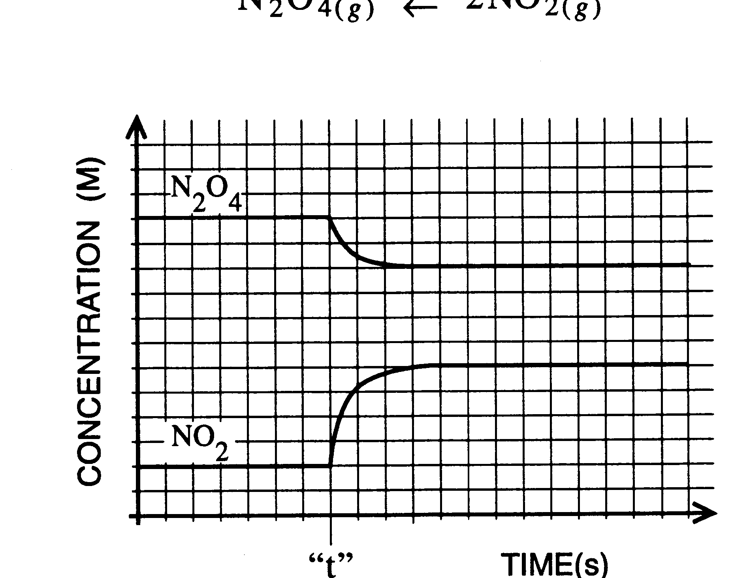

At time = “t”, which of the following disturbances occurred?

  - catalyst was added
  - pressure was changed
  - temperature was changed
  - concentration of NO₂ was changed

- What is the pH of a solution prepared by adding 0.50 mol KOH to 1.0 L of 0.30 mol L⁻¹ HNO₃?

  - 0.20
  - 0.70
  - 13.30
  - 13.80

- Separate solutions of the following salts are prepared, each solution having a concentration of 0.10 mol L⁻¹. Which solution has the highest pH?

  - KCl
  - NaF
  - Pb(NO₃)₂
  - NH₄Cl

- The conjugate base of H₂BO₃⁻ is

  - HBO₃²⁻
  - H₃BO₃
  - H₃BO₃⁻
  - BO₃³⁻

- The titration curve illustrated below corresponds to which type of titration?
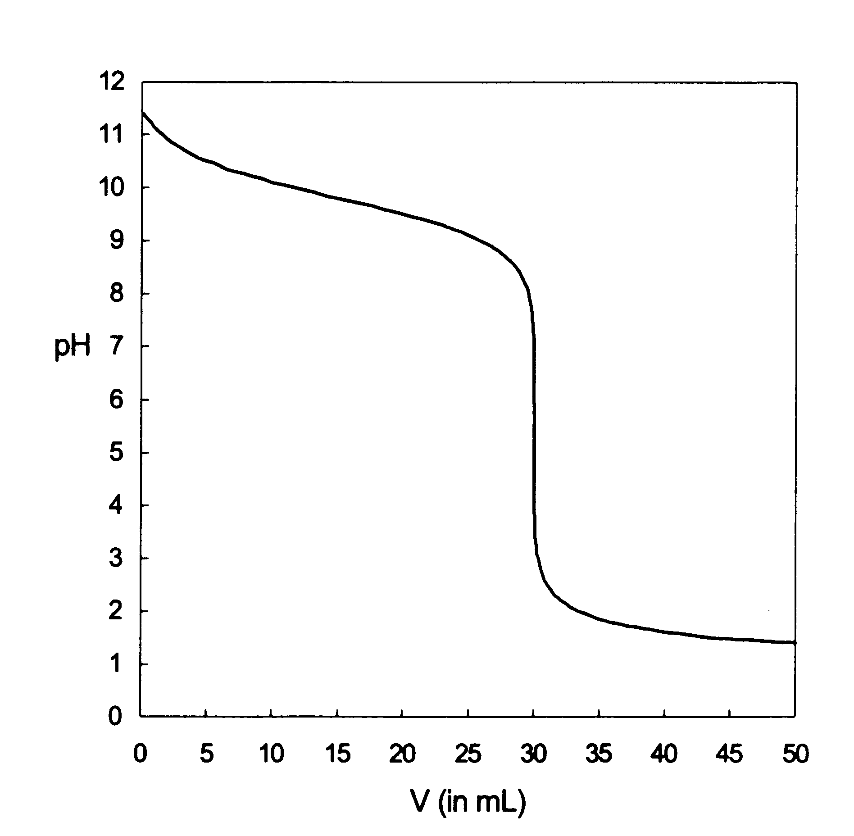

  - weak base by weak acid
  - weak acid by strong base
  - strong base by strong acid
  - weak base by strong acid

- Consider the following redox reaction:

The species which loses electrons is

  - Cl₂
  - Cr³⁺
  - H₂O
  - Cr₂O₇²⁻

- Which of the following represents a redox reaction?

- Consider the following redox reaction:

(basic)

The reduction half-reaction that occurs is

- Consider the following redox reaction:

The reducing agent is

  - H₂O
  - ClO₃⁻
  - MnO₂
  - MnO₄⁻

- As SO₄²⁻ changes to SO₃²⁻, it is said that sulfur is being reduced since its oxidation number

  - increases as electrons are lost
  - decreases as electrons are lost
  - increases as electrons are gained
  - decreases as electrons are gained

- In the chemistry world, pool “chlorine” is the following equilibrium system:

(a)
(b)
(c)
(d)

- Gold is separated from ore by oxidizing the gold using which oxidizing agent?

  - O₂
  - Cr₂O₇²⁻
  - H₂O
  - CN⁻

- In the extraction of iron using the blast furnace technique, the production of carbon monoxide occurs because of the presence of

  - suitable catalysts
  - limited air
  - limited carbon
  - both (b) and (c)

- In the blast furnace for iron production

  - SiO₂ reacts with CaO to form a low density slag
  - SiO₂ reacts with CaO to form a high density slag
  - SiO₂ reacts with CaCO₃ to form a high density slag
  - SiO₂ reacts with CaCO₃ to form a low density slag

END OF PART 1
PART 2 (70 marks)
Answer ALL questions in Part 2 in the spaces provided below.
____________________________________________________________________________

1. Write equations for any reactions that occur in the following procedures. If no reaction occurs write 'no reaction'.

In each case describe in full what you would observe, including any
- colours
- odours
- precipitates (give the colour)
- gases evolved (give the colour or describe as colourless).

If no change is observed, you must state this as the observation.

(a) Dilute hydrochloric acid is added to solid sodium carbonate.

Equation ________________________________________________________________

Observation ______________________________________________________________

________________________________________________________________________
[3 marks]

(b) An excess of ammonia is slowly added to solid zinc hydroxide.

Equation ________________________________________________________________

Observation ______________________________________________________________

________________________________________________________________________
[3 marks]

(c) Dilute sodium hydroxide is added to a small amount of chromium metal.

Equation ________________________________________________________________

Observation ______________________________________________________________

________________________________________________________________________
[3 marks]

(d) Hot concentrated sulphuric acid is added to a piece of copper.

Equation ________________________________________________________________

Observation ______________________________________________________________

________________________________________________________________________
[3 marks]
2. (a) Write ionic equations for the combination of the following solutions:

- copper(II) sulfate and lithium sulfide [1 mark]

___________________________________________________________________

(ii) magnesium chloride and silver nitrate [1 mark]

___________________________________________________________________

(iii) acetic acid and sodium hydroxide [1 mark]

___________________________________________________________________

(iv) ammonia and sulfuric acid [1 mark]

___________________________________________________________________

(v) sodium sulfate and barium nitrate [1 mark]

___________________________________________________________________

(b) Balance the following equation by giving the values of the coefficients: W, X, Y and Z:

W Al(s) + X Fe₃O₄(s) -------> Y Al₂O₃(s) + Z Fe(s) [2 marks]

W = ______

X = ______

Y = ______

Z = ______

(c) Write a chemical equation that shows the dissociation of calcium chloride. [1 mark]

______________________________________________________________________

(d) What is the pCl of a 0.01 M solution of NaCl? _________ [1 mark]
3. Using the collision theory, explain why a mixture of natural gas and air does not react at room temperature but explodes when a piece of platinum is placed in the gas mixture.

[3 marks]

_________________________________________________________________________

_________________________________________________________________________

_________________________________________________________________________

_________________________________________________________________________

_________________________________________________________________________

_________________________________________________________________________

_________________________________________________________________________

  - 10.0 g of scrap copper water pipe was dissolved in a beaker containing 500 mL of 2.00 mol L⁻¹ nitric acid according to the following equation:

The changing mass of the mixture was observed against time, and the following graph obtained:

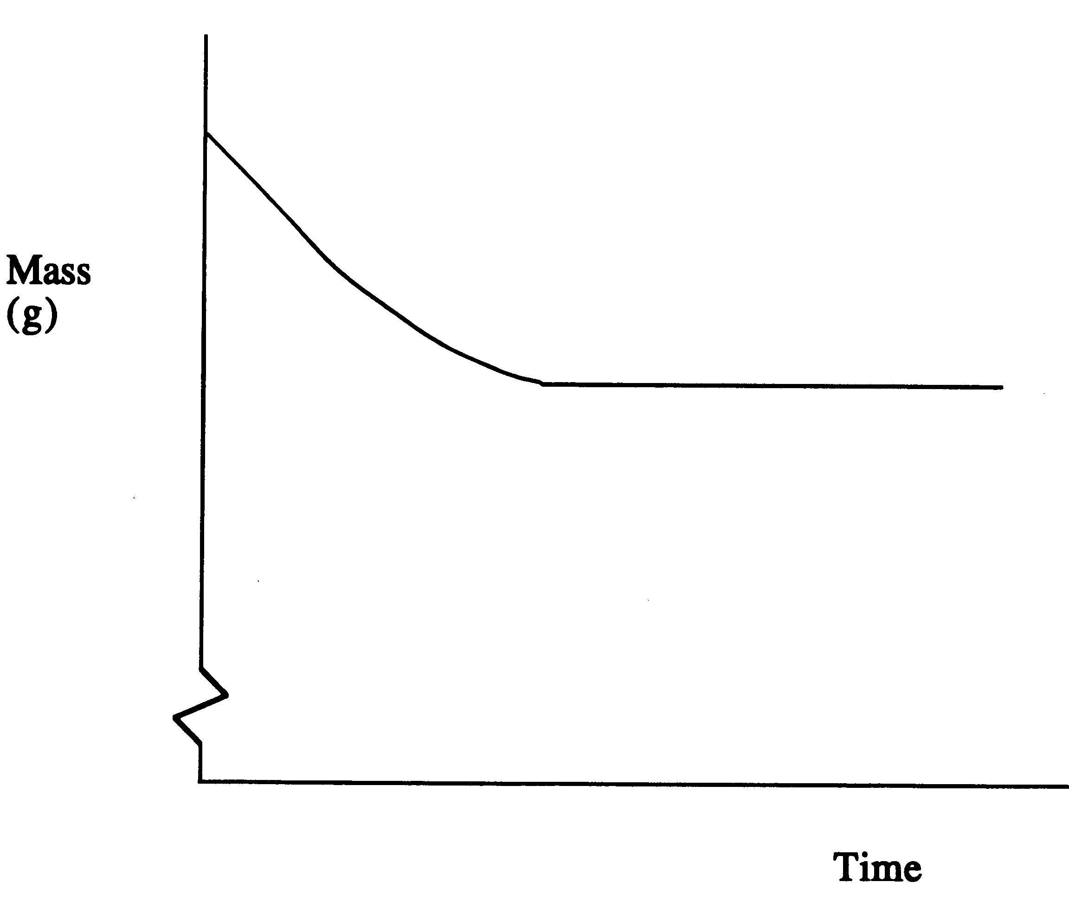
- On the graph sketch the expected curve if 500 mL of 1.00 mol L⁻¹ nitric acid had been used instead. Label your new graph line.
[2 marks]
Explain the difference in shape.

______________________________________________________________________

______________________________________________________________________

______________________________________________________________________

______________________________________________________________________

______________________________________________________________________

- Show on the graph the expected line if the 10.0 g of scrap copper had previously been ground up in a hammer mill. Label this graph line. Explain.
[2 marks]

______________________________________________________________________

______________________________________________________________________

______________________________________________________________________

______________________________________________________________________

______________________________________________________________________

  - A nitrogen dioxide molecule can collide with a carbon monoxide molecule as follows:

- For this reaction, ΔH = -225 kJ mol⁻¹ and the activation energy is 125 kJ mol⁻¹. What is the activation energy for the reverse reaction?
[1 mark]

______________________________________________________________________

- What energy changes take place as the nitrogen dioxide and carbon monoxide molecules approach each other?
[2 marks]

______________________________________________________________________

______________________________________________________________________

______________________________________________________________________

  - Consider the following steps in a chemical reaction:

Step 1:
Step 2:

Which species is the catalyst? Explain.
[2 marks]

_________________________________________________________________________

_________________________________________________________________________

_________________________________________________________________________

_________________________________________________________________________

  - Sufficient hydrogen chloride gas an oxygen gas are introduced into a container and the temperature held constant at 450ºC, and the pressure adjusted to 101.3 kPa until equilibrium is attained, according to the reaction:

ΔH = -117.6 kJ

(a) Write an expression for the equilibrium constant, K. [1 mark]

______________________________________________________________________

(b) How will the equilibrium constant at 550ºC compare with the value at 450ºC (the pressure remaining constant at 101.3 kPa)? Explain.
[3 marks]

______________________________________________________________________

______________________________________________________________________

______________________________________________________________________

______________________________________________________________________

______________________________________________________________________

______________________________________________________________________

______________________________________________________________________

______________________________________________________________________

______________________________________________________________________

______________________________________________________________________
(c) The volume is expanded at constant temperature so that the pressure is decreased. The system is allowed to resettle to equilibrium. How will the concentration of the reactant gases and product gases at this new equilibrium compare with their concentrations at the initial equilibrium? Give reasons.
[3 marks]

______________________________________________________________________

______________________________________________________________________

______________________________________________________________________

______________________________________________________________________

______________________________________________________________________

______________________________________________________________________

______________________________________________________________________

______________________________________________________________________

______________________________________________________________________

______________________________________________________________________

(d) Compare K of part (c) above to the initial value of part (a). [1 mark]

______________________________________________________________________

______________________________________________________________________

- For the similar equilibrium between hydrogen bromide gas and oxygen:

What property of the system could you make use of in order to determine any change in the position of the equilibrium?
[1 mark]

______________________________________________________________________

______________________________________________________________________

- What is “equal” in a chemical reaction that has reached a state of equilibrium?

[2 marks]

______________________________________________________________________

______________________________________________________________________

- Use half equations to balance the following equation in a basic environment. Make sure all working is shown. Marks will also be awarded for clear indication of oxidation numbers for each of the atoms in the equation.

[12 marks]

_________________________________________________________________________

_________________________________________________________________________

_________________________________________________________________________

_________________________________________________________________________

_________________________________________________________________________

_________________________________________________________________________

_________________________________________________________________________

_________________________________________________________________________

_________________________________________________________________________

_________________________________________________________________________

_________________________________________________________________________

_________________________________________________________________________

_________________________________________________________________________

_________________________________________________________________________

_________________________________________________________________________

_________________________________________________________________________

_________________________________________________________________________

_________________________________________________________________________
- (a) Why is hypochlorous acid able to destroy algae and bacteria in water? Why is it more effective than hypochlorite ion?
[2 marks]

______________________________________________________________________

______________________________________________________________________

______________________________________________________________________

(b) What are the three raw materials fed into a blast furnace?
[3 marks]

______________________________________________________________________

______________________________________________________________________

- Write the chemical equation that takes place by the BOS for the removal of silicon in pig iron.
[1 mark]

______________________________________________________________________

- (a) Write an equation to show the production of the main contaminant that is often found in storage bottles containing potassium permanganate solutions.
[2 marks]

______________________________________________________________________

______________________________________________________________________

______________________________________________________________________

(b) Describe the procedure used to prepare a potassium permanganate solution. Explain why the various steps are taken.
[6 marks]

______________________________________________________________________

______________________________________________________________________

______________________________________________________________________

______________________________________________________________________

______________________________________________________________________

______________________________________________________________________

END OF PART 2
PART 3 (50 marks)

Answer ALL questions in Part 3. The calculations are to be set out in detail in this Question/Answer Booklet. Marks will be allocated for correct equations and clear setting out, even if you cannot complete the problem. When questions are divided into sections, clearly distinguish each section using (a), (b), and so on. Express your final numerical answers to three (3) significant figures where appropriate, and provide units where applicable. Information which may be necessary for solving the problems is located on the separate Chemistry Data Sheet. Show clear reasoning: if you don’t, you will lose marks.
____________________________________________________________________________

- Calculate the density of NO₂ gas at 1.00 atm and 35ºC.
[3 marks]

_________________________________________________________________________

_________________________________________________________________________

_________________________________________________________________________

_________________________________________________________________________

_________________________________________________________________________

_________________________________________________________________________

- A 16.0 mol L⁻¹ solution of nitric acid contains 70% HNO₃ by mass. Calculate the density of the solution.
[4 marks]

_________________________________________________________________________

_________________________________________________________________________

_________________________________________________________________________

_________________________________________________________________________

_________________________________________________________________________

_________________________________________________________________________

_________________________________________________________________________

_________________________________________________________________________

_________________________________________________________________________

_________________________________________________________________________
- 3.72 litres of carbon dioxide gas at 27ºC at 154.2 kPa has 4.52 grams of sodium added to it. The sodium is ignited and reacts with the carbon dioxide according to the following equation:

Calculate the mass of sodium carbonate produced and the number of moles of excess reagent remaining after the reaction.
[6 marks]

_________________________________________________________________________

_________________________________________________________________________

_________________________________________________________________________

_________________________________________________________________________

_________________________________________________________________________

_________________________________________________________________________

_________________________________________________________________________

_________________________________________________________________________

_________________________________________________________________________

_________________________________________________________________________

_________________________________________________________________________

_________________________________________________________________________

_________________________________________________________________________

_________________________________________________________________________

_________________________________________________________________________

_________________________________________________________________________

_________________________________________________________________________

_________________________________________________________________________

_________________________________________________________________________

_________________________________________________________________________

- A particular ore contains 47.2% MnO₂. What mass of the ore must be refined to produce 2.50 tonnes of pure manganese metal?
[6 marks]

_________________________________________________________________________

_________________________________________________________________________

_________________________________________________________________________

_________________________________________________________________________

_________________________________________________________________________

_________________________________________________________________________

_________________________________________________________________________

_________________________________________________________________________

_________________________________________________________________________

_________________________________________________________________________

_________________________________________________________________________

_________________________________________________________________________

_________________________________________________________________________

_________________________________________________________________________

_________________________________________________________________________

_________________________________________________________________________

_________________________________________________________________________

_________________________________________________________________________

_________________________________________________________________________

_________________________________________________________________________

_________________________________________________________________________

_________________________________________________________________________

_________________________________________________________________________

- A chemist wants to determine the percentage of cerium(III) and cerium(IV) in a sample containing Ce(NO₃)₃, CeCl₄ as well as some non-cerium impurities. He dissolves 2.167 grams of the sample in water and adds potassium bromate to oxidise all cerium(III) to cerium(IV). Enough potassium iodate is then added to precipitate out the cerium(IV) as cerium(IV) iodate, Ce(IO₃)₄. He collects the solid by filtration and places the solid with its filter paper into a beaker. To this he adds a quantity of oxalic acid, C₂H₂O₄, in order to remove iodine from the system. The chemical reaction that takes place is as follows:

The system is boiled to make sure all dissolved iodine is removed. It is then filtered to collect the solid. The solid CeO₂ is placed in an oven at 500ºC to drive off any organic impurities. The solid CeO₂ is then weighed and found to have a mass of 2.312 grams.

The chemist then takes 1.528 grams of the original sample and analyses it for its nitrate content. The mass of the nitrate ion in this quantity is found to be 0.5230 grams.

- Calculate the percentage by mass of cerium(III) as well as the percentage by mass of cerium(IV) in the original sample.
[11 marks]

- Calculate the pressure (in kPa) of iodine gas generated if it is collected during the procedure and occupies a volume of 255.4 ml at 25ºC.
[2 marks]

_________________________________________________________________________

_________________________________________________________________________

_________________________________________________________________________

_________________________________________________________________________

_________________________________________________________________________

_________________________________________________________________________

_________________________________________________________________________

_________________________________________________________________________

_________________________________________________________________________

_________________________________________________________________________

_________________________________________________________________________

_________________________________________________________________________

_________________________________________________________________________

_________________________________________________________________________

_________________________________________________________________________

_________________________________________________________________________

_________________________________________________________________________

_________________________________________________________________________

_________________________________________________________________________

_________________________________________________________________________

_________________________________________________________________________

_________________________________________________________________________

_________________________________________________________________________

_________________________________________________________________________

_________________________________________________________________________

_________________________________________________________________________

_________________________________________________________________________

_________________________________________________________________________

_________________________________________________________________________

_________________________________________________________________________

_________________________________________________________________________

_________________________________________________________________________

_________________________________________________________________________

_________________________________________________________________________

_________________________________________________________________________

_________________________________________________________________________

_________________________________________________________________________

_________________________________________________________________________
- The nitrogen content of a 0.895 g sample of dried protein was determined by converting all the nitrogen in the protein into ammonia gas. The ammonia was then bubbled through 50.0 ml of 0.1970 mol L⁻¹ hydrochloric acid causing a reaction to occur between the two species. After the ammonia had reacted there was some hydrochloric acid remaining. This was neutralised by titrating with 5.90 ml of 1.028 mol L⁻¹ sodium hydroxide solution. Calculate the percentage by mass of nitrogen in the sample of dried protein. In this question marks will be allocated for chemical equations shown.
[10 marks]

_________________________________________________________________________

_________________________________________________________________________

_________________________________________________________________________

_________________________________________________________________________

_________________________________________________________________________

_________________________________________________________________________

_________________________________________________________________________

_________________________________________________________________________

_________________________________________________________________________

_________________________________________________________________________

_________________________________________________________________________

_________________________________________________________________________

_________________________________________________________________________

_________________________________________________________________________

_________________________________________________________________________

_________________________________________________________________________

_________________________________________________________________________

_________________________________________________________________________

_________________________________________________________________________

_________________________________________________________________________

_________________________________________________________________________

_________________________________________________________________________

_________________________________________________________________________

_________________________________________________________________________

_________________________________________________________________________

_________________________________________________________________________

_________________________________________________________________________

_________________________________________________________________________

_________________________________________________________________________

_________________________________________________________________________

_________________________________________________________________________

_________________________________________________________________________

_________________________________________________________________________

_________________________________________________________________________

_________________________________________________________________________

_________________________________________________________________________

_________________________________________________________________________

_________________________________________________________________________

_________________________________________________________________________

_________________________________________________________________________

_________________________________________________________________________

_________________________________________________________________________

_________________________________________________________________________

_________________________________________________________________________

_________________________________________________________________________

_________________________________________________________________________
- A solution is to be analysed for its potassium persulfate content by a titration technique. A volume of 50 ml is pipetted from the solution into a 500 ml flask which is then made up to the mark with distilled water. An aliquot of 25 ml of this diluted solution is placed into a conical flask. 50 ml of 0.0931 mol L⁻¹ FeSO₄ in an acidic environment is also added to the flask so that all the persulfate is reduced as described by the following equation:

The excess iron(II) that remains after the reaction is titrated against 0.0194 mol L⁻¹ potassium permanganate. The volume of permanganate at the end point is found to be 21.08 ml. The following equation describes the reaction:

From this information calculate the concentration of potassium persulfate in the original solution.
[8 marks]

_________________________________________________________________________

_________________________________________________________________________

_________________________________________________________________________

_________________________________________________________________________

_________________________________________________________________________

_________________________________________________________________________

_________________________________________________________________________

_________________________________________________________________________

_________________________________________________________________________

_________________________________________________________________________

_________________________________________________________________________

_________________________________________________________________________

_________________________________________________________________________

_________________________________________________________________________

_________________________________________________________________________

_________________________________________________________________________

_________________________________________________________________________

_________________________________________________________________________

_________________________________________________________________________

_________________________________________________________________________

_________________________________________________________________________

_________________________________________________________________________

_________________________________________________________________________

_________________________________________________________________________

_________________________________________________________________________

_________________________________________________________________________

_________________________________________________________________________

_________________________________________________________________________

_________________________________________________________________________

_________________________________________________________________________

_________________________________________________________________________

_________________________________________________________________________

_________________________________________________________________________

_________________________________________________________________________

_________________________________________________________________________

_________________________________________________________________________

_________________________________________________________________________

_________________________________________________________________________

_________________________________________________________________________

_________________________________________________________________________

END OF PART 3

PART 4 (20 marks)

Answer ONE of the following extended answer questions. Where applicable use equations, diagrams and illustrative examples of the chemistry you are describing.

Marks are awarded for the relevant chemical content of your answer, but also for coherence and clarity of expression. Your answer should be presented in about 1.5 - 2 pages. Begin your essay on the lined page following the end of the questions.
____________________________________________________________________________

- “The industrial production of compounds is a compromise between reaction rate requirements, equilibrium requirements and economic requirements.” Explain this statement using as examples the processes and conditions used in the Haber and Contact processes. Make sure you explain the chemistry behind the statements you have made.

OR

- Give a detailed account of the laboratory procedures that you would use to determine the percentage by mass of acetic acid in vinegar. Your response must include the preparation/analysis of primary and secondary standards. Furthermore, include in your answer any relevant chemical equations. Identify sources of error in the procedure and describe how you would minimise such errors. You are NOT required to give an example of the calculations involved in this analysis.

END OF QUESTIONS
Check that you have written your Name on the front cover of this booklet
Write your response to Part 4 below.

____________________________________________________________________________

____________________________________________________________________________

____________________________________________________________________________

____________________________________________________________________________

____________________________________________________________________________

____________________________________________________________________________

____________________________________________________________________________

____________________________________________________________________________

____________________________________________________________________________

____________________________________________________________________________

____________________________________________________________________________

____________________________________________________________________________

____________________________________________________________________________

____________________________________________________________________________

____________________________________________________________________________

____________________________________________________________________________

____________________________________________________________________________

____________________________________________________________________________

____________________________________________________________________________

____________________________________________________________________________

____________________________________________________________________________

____________________________________________________________________________

____________________________________________________________________________

____________________________________________________________________________

____________________________________________________________________________

____________________________________________________________________________

____________________________________________________________________________

____________________________________________________________________________

____________________________________________________________________________

____________________________________________________________________________

____________________________________________________________________________

____________________________________________________________________________

____________________________________________________________________________

____________________________________________________________________________

____________________________________________________________________________

____________________________________________________________________________

____________________________________________________________________________

____________________________________________________________________________

____________________________________________________________________________

____________________________________________________________________________

____________________________________________________________________________

____________________________________________________________________________

____________________________________________________________________________

____________________________________________________________________________

____________________________________________________________________________

____________________________________________________________________________

____________________________________________________________________________

____________________________________________________________________________

____________________________________________________________________________

____________________________________________________________________________

____________________________________________________________________________

____________________________________________________________________________

____________________________________________________________________________

____________________________________________________________________________

____________________________________________________________________________

____________________________________________________________________________

____________________________________________________________________________

____________________________________________________________________________

____________________________________________________________________________

____________________________________________________________________________

____________________________________________________________________________

____________________________________________________________________________

____________________________________________________________________________

____________________________________________________________________________

____________________________________________________________________________

____________________________________________________________________________

____________________________________________________________________________

____________________________________________________________________________

____________________________________________________________________________

____________________________________________________________________________

____________________________________________________________________________

____________________________________________________________________________

____________________________________________________________________________

____________________________________________________________________________

____________________________________________________________________________

____________________________________________________________________________

____________________________________________________________________________

____________________________________________________________________________

____________________________________________________________________________

____________________________________________________________________________

____________________________________________________________________________

____________________________________________________________________________

____________________________________________________________________________

____________________________________________________________________________

____________________________________________________________________________

____________________________________________________________________________

____________________________________________________________________________

____________________________________________________________________________

____________________________________________________________________________

____________________________________________________________________________

____________________________________________________________________________

____________________________________________________________________________

____________________________________________________________________________

____________________________________________________________________________

____________________________________________________________________________

____________________________________________________________________________

____________________________________________________________________________

____________________________________________________________________________

____________________________________________________________________________

____________________________________________________________________________

____________________________________________________________________________

____________________________________________________________________________

____________________________________________________________________________

____________________________________________________________________________

____________________________________________________________________________

____________________________________________________________________________

____________________________________________________________________________

____________________________________________________________________________

____________________________________________________________________________

____________________________________________________________________________

____________________________________________________________________________

____________________________________________________________________________

____________________________________________________________________________

____________________________________________________________________________

____________________________________________________________________________

____________________________________________________________________________

____________________________________________________________________________

____________________________________________________________________________

____________________________________________________________________________

____________________________________________________________________________

____________________________________________________________________________

____________________________________________________________________________

____________________________________________________________________________

____________________________________________________________________________

____________________________________________________________________________

____________________________________________________________________________

____________________________________________________________________________

____________________________________________________________________________

____________________________________________________________________________

____________________________________________________________________________

____________________________________________________________________________

____________________________________________________________________________

____________________________________________________________________________

____________________________________________________________________________

____________________________________________________________________________

____________________________________________________________________________

____________________________________________________________________________

____________________________________________________________________________

____________________________________________________________________________

____________________________________________________________________________

____________________________________________________________________________

____________________________________________________________________________

____________________________________________________________________________

____________________________________________________________________________

____________________________________________________________________________

____________________________________________________________________________

____________________________________________________________________________

____________________________________________________________________________

____________________________________________________________________________

